INTERACTIVE TEXT BASED QUERY CHATBOT SYSTEM: TO HELP ANSWER STUDENT FREQUENTLY ASKED QUESTIONS AT THE UNIVERSITY OF NAMIBIA

FACULTY OF SCIENCE: SCHOOL OF COMPUTING

CIT 3810: RESEARCH PROJECT

A PROJECT PROPOSAL SUBMITTED IN PARTIAL FULFILLMENT OF THE REQUIREMENTS FOR THE BACHELOR OF SCIENCE (HONOURS) DEGREE IN INFORMATION TECHNOLOGY

OF

THE UNIVERSITY OF NAMIBIA

BY

TANGENI THOMAS EGUMBO

STUDENT NO: 201402247

MARCH 2018

SUPERVISOR: DR. NALINA SURESH

Table of Contents

**Abstract** i

**1.** **Introduction** 1

1.1 Motivation 1

1.2 Statement of the problem 2

1.3 Objectives 2

1.3.1 Sub objectives: 2

1.4 Significance of the study 2

1.5 Limitation of the study 3

**2.** **Literature Review** 3

**3. Methodology** 5

3.1Research Design 5

3.2 Development Methodology 6

3.3 Requirements phase 7

3.4 Use cases 8

3.4.1 Uses cases description 8

4. Design Phase 9

4.4.1 Implementation 10

4.4.2 Testing 10

4.4.3 Evaluation 11

**5. Project Schedule** 11

**6. Research Ethics** 12

**7. References** 12

# **Abstract**

Traditional Phenomenon at University of Namibia is very worrying fact of getting information or enquiry about any problem that a student might have, the only way is by going physically to the University. Upon going to the university in order to get information or enquire about anything that you want, one has to queue up for that which is time consuming and sometimes one have to pay to go to this places physical which is sometimes unnecessary. The purpose of this project is to identify the features as well as the benefit of using a Student information/Query chatbot system.

Research suggests that the development of an Information/Enquiry Chatbot system could help resolve the traditional way of assisting students with enquiries, The chat bot application helps the students to access the university related information from anywhere with internet connection. The system will avoid the queuing for information. The main goal of this project is to ease the burden of continuous calls and e-mails on institute authorities and at the same time make it easier for the students to conveniently retrieve information without having to look or browse several webpages to fetch answers and not to stand in queues to ask for questions. The system will help the student to have an interactive platform with the chatbot system, this automatic answering system reduces burden on University officials providing information to students and also reduces the dependency on humans to answer the queries

# **Introduction**

In today’s world computers play an important role in our society by providing us with information. A chatbot (also known as a talk bot, Bot, chatterbox, Artificial Conversational Entity) is a program designed to counterfeit a smart communication on a text or speech [1] [2]. Chatbot technologies have existed since the 1960’s and have influenced user interface development in games since the early 1980’s, however chatbots are not fully explored using API’s on SaaS Cloud services [3]. Chatbots recognize the user input as well as by using pattern matching to provide a predefined acknowledgment. For example, if the user is providing the bot with a sentence like “What is your name?” the chatbot is most likely to reply something like “My name is Chatbot.” or “You can call me Chatbot.” based on the sentence given by the user [4]. Chatbots talk in almost every major language. Their Natural Language Processing (NLP) skills vary from extremely poor to very clever, intelligent, helpful and funny. The proposed chatbot will be built using artificial algorithms that analyze user`s queries and understand user`s message. This System will be a messenger application which provides answers to queries given by University of Namibia (UNAM) students. Students just have to put their query(s) to the bot, which is used for chatting. It will use the artificial intelligence algorithms to give appropriate answers to the user. When chatbot technology is integrated with popular web service platforms it can be utilized securely by an even larger audience.

## 1.1 Motivation

Research through observation has shown that during the period of registration at (UNAM) Main Campus, there are usually students at the Administration (Admin) Block standing in long lines of queues. Some students are usually not from the Main Campus, but since it’s the only place where they can get help, the students have to come line up in long queues. This process of assisting students can be very stressful and time consuming for both, students and university officials. The main motivation is to find a way to solve this issue on UNAM main Campus. Another motivation is in the researcher`s interest in the development of chatbot application(s).

## 1.2 Statement of the problem

A number of students during the registration process are not usually in Windhoek. They will be on holidays or even working in places far from the Main campus in Windhoek. Hence most of the students can`t make it physically to the University. Some make use of the telephone line, but they find themselves not being helped because the line is busy most of the time. The issue of having to go to a place physically can be very daunting for individuals, and upon their arrival, there is a queue which one can’t avoid. A student, therefore, has to wait in the line to ask questions or get clarification. The communication of potential students with the university administration is performed manually and it is a very time consuming procedure. With many hundreds of students each year, one-to-one conversations are generally not feasible. Therefore, developing an application such as this can help improve the process of having students or an individual to physically be at a place to ask for information and clarity.

## 1.3 Objectives

The main and Sub-objective of this Study are:

*TO DESIGN A CHATBOT APPLICATION FOR UNIVERSITY OF NAMIBIA STUDENTS IN MAIN CAMPUS*

### Sub objectives:

* To identify the appropriate tools (database) that will facilitate the development of the chatbot application
* To determine an AI.api(application Programming Interface) algorithm that can be implemented in a chatbot application to compare the queries asked by students to the chatbot
* ~~To find the frequently asked questions from the Students as well as UNAM enquiry officials~~.
* To develop a peer to peer (p2p) chatbot application which replies to the user with relevant answers based on the history of frequently asked questions. .

## Significance of the study

This study only focuses on how a chatbot app can be used by University students and University administration block to help resolve the current problem Students are experiencing. The research objectives above will help provide a guideline which will give us a rational scope. This project will focus on frequently asked information and queries and their solutions thereof.

## 1.5 Limitation of the study

This project will only focus on frequently asked questions and queries and other related information/queries will be included in future work as a result of the limited scopes of the propose project. Proposed study is based on a text only chatbot. Another limitation will be the population sample which might not be as representative of the actual UNAM main campus students.

# **Literature Review**

In this section a Literature review is presented based on previous relate work/studies that have been done, a brief description of how they work and what technologies/Techniques where used.

One of the first and most famous chatbot was “ELIZA” [5], done by Joseph Weizenbaum. It aimed to simulate a psycho-analyst by rephrasing many of the patient's statements as questions, and then posing them to the patient. Further in this study if a keyword was not present then ELIZA would try, according to specified rules, to get more information from the user to keep the conversation going. Initially, in this study a simple keyword matching algorithm was used to find and answer to a user query. This chatbot applied a user-supplied corpus to respond to questions or statements posed by the user.

According to Bani et al. [6], chatbot ALICE study, a proposal was carried on to explain the design of a chatbot specifically tailored as an application which is going to help new students to solve all the problems they face, and the questions which arises in their mind during and after the admission. In particular, the proposal investigates the implementation of ALICE chatbot system based on natural language understanding and pattern matching. To add, the architecture of the chatbot engine and the language knowledge model are clearly separated, the knowledge based of ALICE is implemented using Artificial Intelligence Markup Language (AIML) files, this application is named as “College Enquiry Chatbot”. Atwell et al [7] states that, if we consider ALICE, it basically generates an AIML file from a dialogue corpus with patterns and templates.

Another study similar to college enquiry chatbot is called “College Chatbot”. The College Chatbot system is a web application which provides answers to the query of the student [8]. The College Chatbot was built using artificial intelligence that analyses user`s queries and understand user`s message. The user has to register himself to the system and login to the system to access various helping pages. The college queries were related on activities such as date and timing of annual day, sports day and other cultural activities.

This study [9] presents a survey on chatbot Design Techniques in Speech Conversation systems. Further the study presents the split of chatbot speech interaction into more than one area use of which includes: speech recognition, speech parsing, Natural Language Processing (NPL), keyword identification, Chatbot design/personality, artificial intelligence etc. Further in the study they mention the use of speech recognition as the widely accepted as the future of interaction with computers and it can help disabled people with paralysis, a use of Natural Language Toolkit (NTLK) in order to deal with and manipulate the text resulting from speech recognition and speech to text conversation. In addition, the study also presents their new approach to chatbot design which combines indexing and query matching methods with pattern matching and applies Information Retrieval (IR) techniques to produce a new sentence from an existing one.

In the same respect, Chantarotwong [10] reported that “responses of most chatbots are frequently predictable, redundant, lacking in personality, and having no memory of previous responses which could lead to very circular conversation”. All these chatbots function similarly, the limitation begins from the presence of a corpus which assumes all knowledge comes from previous dialogue done by human agents. Secondly generating AIML from a corpus cannot guarantee a coherent chat because there is a fear of getting repetitive statements, which may worsen the user`s chat experience. According to Shawar [5] states that, primitive systems like ELIZA used keyword matching and minimal context identification and lacked the ability to keep a conversation going. Studies [5], [6], [8] show that there`s a lack of intelligence as well as most chatbots are unable to detect spelling errors and grammar mistakes, similar responses for repetitive statements due to the pattern matching nature of AIML was also a defect. In addition, ALICE does not truly understand what you said, it gives you the responses from the knowledge domain stored in her brain “brain” (database).According to the study [8] a user has to register himself to the system and login to the system to access, but the proposed system would not have that functionality. The study [9] presents speech recognition which is limited to the proposed study, since the proposed study will only focused on text-based query.

The proposed system would make use of a chatbot design which combines indexing and AI Application Programming Interface (API) algorithms for query matching methods with pattern matching and use Information Retrieval (IR) techniques. The proposed system is also going to make use of an instant Facebook messaging application, open source software (Artificial Intelligence) and Natural Language processing (NLP). The proposed chatbot would be design to meet certain needs, which can be used by UNAM main campus students, and present an alternative method that enhances student’s current process to a better one.

# **3. Methodology**

## 3.1Research Design

The proposed research methodology would be applied research which is also for development purposes. According to [11] “Applied research on the other hand, is to acquire knowledge on the practical application of the theoretical base already built up which is expected to solve a critical problem”. In order to complete this study, apart from experiences and motivation, literature review, objectives and software development methodologies. This study will also need strategies, data generation methods, and data analysis.

## 3.1.1 Research Methods

The method of data generation will be both quantitative and qualitative data.

## 3.1.2 Population

The sample population will include fifty (50) enrolled students and five (5) University Admin block officials. These students would include SADC (Southern African Development Countries) & Non-SADC. This sample is generalizable and representative of the university students in Windhoek at UNAM main campus.

3.1.3 Sample

The sampling techniques which will be used will be non-probabilistic namely: selective sampling, purposive/judgmental and snowballing.

## 3.1.4 Procedure

The method of data generation that would be used in this research are interviews, questionnaires and observations. Interviews will be used as a data collection tool to get the frequently asked questions. Structured format – In the case of a chatbot this would be a question followed by an answer to the proposed question. Observation by naturalistic observation at campus, spending a lot of time around their daily tasks at admin block. Whilst conducting the interviews, we can use snowball sampling by asking participants if they would like to recommend other students in this study.

## 3.1.5 Data Analysis

After the gathering of this data using the different techniques, software tools will be used for analytics such as Microsoft Excel. This will help us draw codes, inferences and answer the proposed research objectives.

## 3.2 Development Methodology

The project is to be developed with agile programming software design method specifically Personal Extreme Programming (PXP).The reason for choosing PXP programming is because it’s the software-development discipline that organizes people to produce robust systems. PXP also attempts to reduce the cost of changes in requirements by having multiple short development cycles, rather than a long one.

This application will be developed under the activities of PXP which include listening where by listening to the user’s feedback, designing whereby creating the user interface, coding whereby coding the application and finally testing whereby testing to determine whether a given feature works as intended and to eliminate flaws. This project is to be developed with ease of use in mind. That it will not be complex for the user to understand and to use. This entire development process is shown in figure 1.

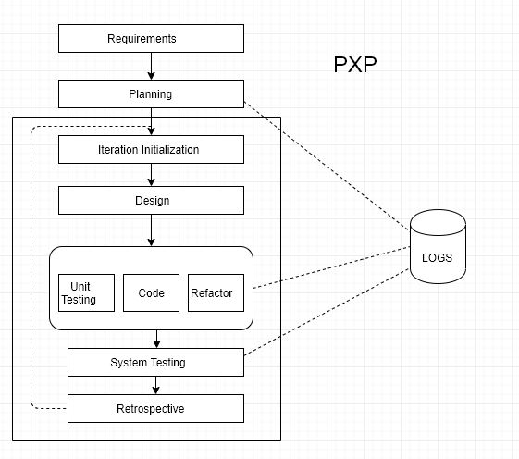

**Figure 1** Process model of PXP

## 3.3 Requirements phase

During the requirements phase, project requirements will be elicited efficiently and effectively. The project requirements will be gathered by analyzing existing systems based on literature review. The research questions, objectives, and problem statement are all included in the requirements. The use case depicted in figure 2. Will explain the proposed solution.

## 3.4 Use cases

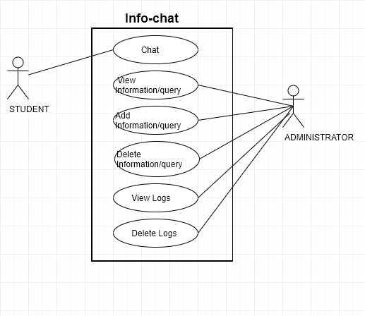

**Figure 2** Use Case Model

### 3.4.1 Uses cases description

|  |  |
| --- | --- |
| Title: | Student Chat |
| Actor | Student |
| Scenario: | 1. Student Query for information. 2. System retrieves information/query to the Student. |

|  |  |
| --- | --- |
| Title: | Update Information/Query |
| Actor | Administrator |
| Scenario: | 1. View information/Query asked by student 2. Update the system answers to the query that are usually asked by student 3. Administrator can delete the conversational logs |

## 3.4 Design Phase

During the design phase of the proposed solution the requirements will be broken down and aligned with the project schedule. A specific design will be chosen for creation. More information about the design will be indicated in order to create the increment. The various tools and software needed to achieve the development of the specified design. Once the design is identified the development can commerce.

The development will be a messenger application in this scenario, the system architecture is shown in figure 3 and Interface API architecture is shown in figure 4.

C:\Users\Arthur\Documents\ACADEMIC\2018\RESEARCH PROJECT\Start\Paper Work Folder\Backend Architecture.png **Figure 3** System architecture

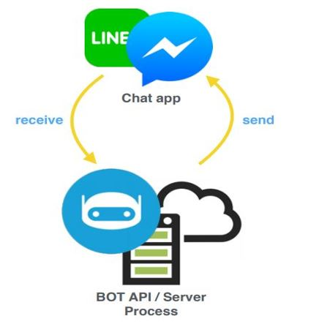

**Figure 4** API Interface architecture [13]

3.5 Implementation

When the researcher has gathered all the project requirements and identified the necessary requirements for developing the system.

The system will be implemented as a messenger app system. The setup of the system will be accessed through a messenger platform, through the use of Facebook, on the phone one has to have Facebook or messenger application installed on the phone. But the system itself will not have to be installed on a pc satisfying the minimal requirements as stated in a project requirements section.

### 3.6 Testing

Testing will be done during coding of the increment/iteration and at the end before releasing the end product. Each incremental/iteration release is tested to determine whether the requirements have been satisfied. Test cases will be written before it is programmed. The proposed prototype testing will be using API(s) (Application Programming Interface(s)).

In addition, the researcher will run a pilot test on a selected group of users, preferable individuals who were involved during the study. This stage will include unit testing, integration testing, system testing and acceptance/user testing. Unit testing to test a small part of the applications overall design or architecture. Integration testing to integrate all the units or small parts into the whole design or architecture. System testing to test the whole system at ones and check for defects within the proposed prototype. Acceptance/user testing to verify that the proposed prototype works and finished correctly.

### 3.7 Evaluation

During the testing stage evaluations will be done seamlessly by both the developer and the users. This is shown using use case diagram in figure 2. this stage makes sure the app conforms the required functionality . The system will be evaluated for effectiveness and efficiency with the students at the University and UNAM admin officials throughout the development life cycle.

The information gathered from the particpants will then be used in the development of the application by using the frequently asked questions and how officials respond to this questions, this will be intergrated into the proposed prototype.

# 

# **5.** **Project Schedule**

The project schedule should reflect all of the work associated with delivering the project on time. The project during with cover the entire year, from February to November 2018. The Gantt chart will be used to graphically depict the project schedule [12].

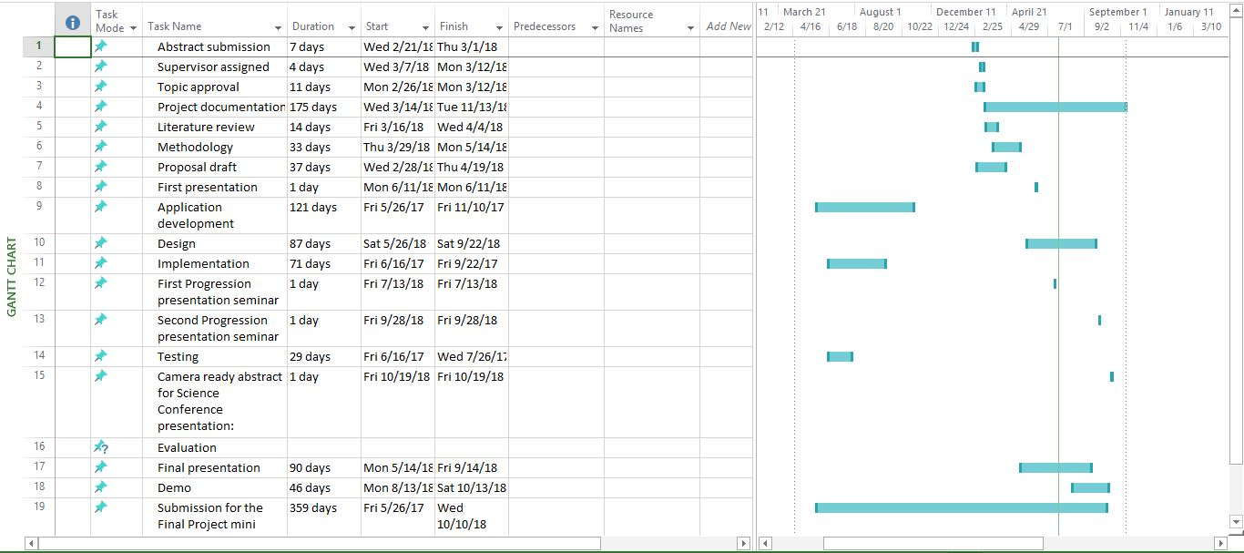

**Figure 4** Proposed Project Schedule (Gantt Chart)

This section describes the hardware and software requirements necessary for the successful completion of the project.

# 

# **6. Research Ethics**

The participants of the proposed study will have the right to know:

That they must first sign an informed consent document, that they may not be coerced into participating in the study, the goals of the study, what will happen to the data that is collected during and after the interview, privacy of their personal information, not to be quoted without their permission, Leave the study when they wish, Be treated politely and safety.

# **7. References**

|  |  |
| --- | --- |
| [1] | L. &. M. D. Bradeško, "A survey of chatbot systems through a loebner prize competition," *In Proceedings of Slovenian Language Technologies Society Eighth Conference of Language Technologies ,* pp. 34-37, 2012. |
| [2] | E. H. a. T. Rebedea, "Designing a Chat-bot that Simulates an Historical Figure," *2013 19th International Conference on Control Systems and Computer Science,* 2013. |
| [3] | H. A.-Z. a. A. A. Issa, "OntBot: Ontology Based Chatbot," *Proc. IEEE of 2011 Fourth International Symposium on Innovation in Information & Communication Technology (ISIICT,* vol. doi:10.1109/ISIICT.2011.6149594, pp. 7-12, 2011. |
| [4] | M. Dahiya, "A Tool of Conversation: Chatbot," *International Journal of Computer Sciences and Engineering,* vol. 5, no. 5, 2017. |
| [5] | E. A. Bayan Abu Shawar, "Chatbots: Are they really useful?," *Penn state University.* |
| [6] | A. P. S. Balbir Singh Bani, "College Enquiry Chatbot Using A.L.I.C.E". |
| [7] | B. A. S. a. E. Atwell, "Using dialogue corpora to train a chatbot," *In proceedings of the Corpus Linguistics 2003 conference,* pp. 681-690, 2003. |
| [8] | A. M. P. ,. V. ,. S. Rachit Kulkarni, "College Chat-bot: This System is a web application which provides answer to the query of the studen," *International Journal of New Technology and Research (IJNTR),* vol. 3, no. 1, pp. 64-65, 2017. |
| [9] | D. J. W. Sameera A. Abdul-Kader, "Survey on Chatbot Design Techniques in Speech," *(IJACSA) International Journal of Advanced Computer Science and Applications,* vol. 6, 2015. |
| [10] | B. Chantarotwong, "The learning chatbot. Final year project," 2005. |
| [11] | R. Paneerselvam, "Research Methodology," in *Prentice Hall of India*, 10th ed., New Delhi, 2012. |
| [12] | "Project, I," 22 April 2016. [Online]. Available: http://www.projectinsight.net/projectmanagement-basics/project-management-schedule. |
| [13] | "The complete beginner’s guide to chatbots," [Online]. Available: https://www.slideshare.net/SikharinCholpratin/chat-bot-get-ready-for-the-next-trend-of-business-en. [Accessed 20 03 2018]. |